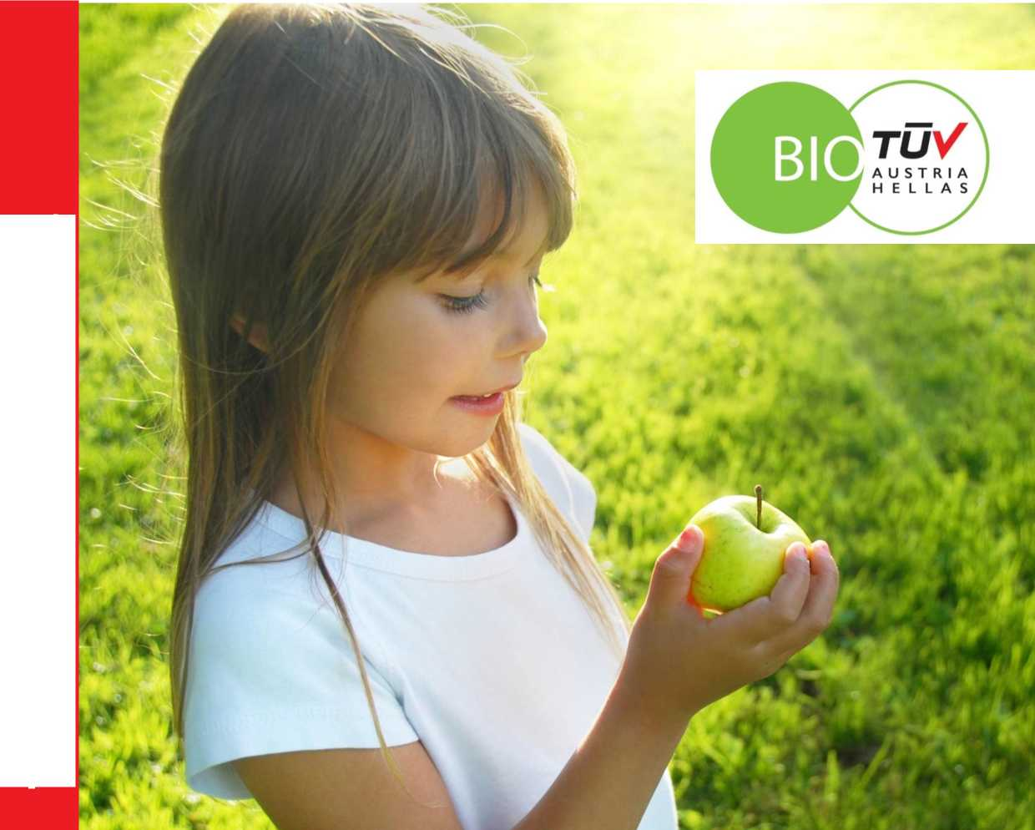
TUV AUSTRIA HELLAS
Regulation on Use of Certification Documents and Seal
Certification of Organic Products
A product of Τϋν AUSTRIA HELLAS
Regulation on the Use of TUV AUSTRIA HELLAS Certification Documents and Seals for Organic Products
- Introduction
The present regulation refers to the use of Certification Documents (Documentary Evidence and Certificate of Compliance) and the seal issued by TÙV AUSTRIA HELLAS to businesses for labelling and advertising their certified organic products.
- Labelling of Organic Products
Labelling of certified organic products is carried out in accordance with the requirements specified in Regulations (EC) No 834/2007 (Articles 23 to 26) and (EC) 889/2008 (Articles 57 to 62), and in National Legislation, as amended and in force at a given time, on the condition that these requirements are met fully throughout the production process.
The compulsory indications on the label of pre-packaged organic products in accordance with the above legislation are:
a) the Community’s organic farming logo, which must be in accordance with the sample of Annex XI part A of Regulation (ΕC) 889/2008
b) the indication of the locale where the plant-product raw materials in the product were farmed
- ‘EU Agriculture’, where the agricultural raw material has been farmed in the EU,
- ‘non-EU Agriculture’, where the agricultural raw material has been farmed in third countries,
- ‘EU/non-EU Agriculture’, where part of the agricultural raw materials has been farmed in the Community and a part of it has been farmed in a third country.
The above mentioned indication ‘EU’ or ‘non-EU’ may be replaced or supplemented by a country in the case where all agricultural raw materials of which the product is composed have been farmed in that country.
c) the code number of the control body to which the operator who has carried out the most recent production or preparation operation is subject. the Τϋν AUSTRIA HELLAS code number is GR-BIO-15
The European Commission has already issued a handbook on the design and use of the EU’s organic farming logo. The handbook is available at:

http://ec.europa.eu/aariculture/oraanic/eupolicy/loao el

- Presentation of the TÙV AUSTRIA HELLAS seal of certification for organic products

TÙV AUSTRIA HELLAS has exclusive ownership of the logo for certification of organic products. Affiliated businesses may use TÙV AUSTRIA HELLAS’s logo certifying organic products on their certified product, in all of the colours specified in the sample below. Its dimensions must be such that it is easily visible to consumers and, at the same time, does not facilitate deception or fraud. Businesses that want to use the TÙV AUSTRIA HELLAS organic product certification logo must follow the other provisions concerning the labelling of organic products deriving from National or Community Legislation.

1. Application on white background
2. Application on dark background | 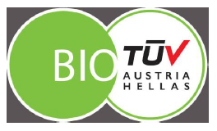
3. Application on coloured background that is the same colour as the logo
4. Application on light background

5. The organic product certification logo can also be printed in silver or gold, as well as in monochrome following the colour of the product label
6. Finally, it can be printed in black and while

- EU Organic Farming logo in combination with the Τϋν AUSTRIA HELLAS Organic Product Certification seal
On organic products, the EU organic farming logo is placed on the product along with the Τϋν AUSTRIA HELLAS Organic Product Certification seal. Below are some possible combinations:

- Use of only the Certified Organic Product seal and/or code of Τϋν AUSTRIA HELLAS
On products with one in-conversion ingredient in organic farming or on foodstuffs of which less than 95% of its ingredients of agricultural origin are organic, the Τϋν AUSTRIA HELLAS Certified Organic Product seal and/or code may be used optionally on product labelling.
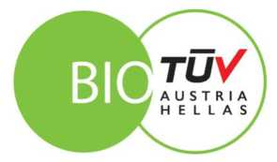
GR-BIO-15

- Regulation on the Use of TUV AUSTRIA HELLAS Certification Documents and Seals for Organic Products
- The business must make claims regarding the certification in accordance with the scope of the application of certification of the products, procedures, processes and units controlled by the Body.
- The business may not use the certification of products, the certification documents issued or the TUVAUSTRIAHELLAS seal for certification of organic products in such a way as to hurt the reputation of TUVAUSTRIAHELLAS; it may not make statements regarding the certification of its products that are misleading or unauthorised according to Regulation (ΕC) 834/2007 and Regulation (ΕC) 889/2008, the National Legislation and the TUVAUSTRIAHELLAS Organic Product Certification Regulation in effect.
- When referring to the certification of products in the news media, such as documents, brochures and advertising (print and/or digital), the business must meet the requirements of Τϋν AUSTRIA HELLAS as these are described in the present Regulation, the Regulation on Certification of Organic Products and the requirements of European and National Legislation on biological farming, as amended and in force at a given time.
- After issuing Documentary Proof, Τϋν AUSTRIA HELLAS gives the right to the business to use the Body’s seal for certification of organic products solely and exclusively in the forms depicted in the present document.
- The right to use the Τϋν AUSTRIA HELLAS certified organic product seal applies exclusively for products, procedures, processes and units audited by the Body and for which valid Documentary Proof has been issued. The seal may not be used for any other product, procedures, processes or units that have not been included in the Documentary Proof.
- The seal must be easily visible and clearly legible. The business does not have the right to alter the seal in any way and is obliged – before using it on labels, advertising materials, letterhead, etc. – to submit a draft design to Τϋν AUSTRIA HELLAS by email at: info@tuvaustriahellas.ar or to contact the Organic Products Department at 210-5220920.

- The Τϋν AUSTRIA HELLAS seal may be used only by the company that has been given the right of use, and only in direct relation to the company name or this seal. Use of the seal cannot be transferred to a third party or successor thereof without the express written consent of the Certification Body.
- The company may provide copies of the certification documents it has been issued to third parties, on the condition that these are copied in their entirety and are not tampered with in any way.
- If claims are made against the Certification Body due to use of the organic product certification seal and/or certification documents of TϋV AUSTRIA HELLAS by the company and in a manner counter to the provisions of the present regulations, the company is obliged release the Certification Body from any responsibility for third-party claims. The same holds true in a case where third-party claims are made against the Certification Body due to claims made by the company in the context of advertising.
- The company is obliged to use the organic product certification seal of TÙV AUSTRIA HELLAS competitively in such a way as to rule out any misinterpretation of the scope of certification.
- The company gains the non-transferable and exclusive right to use visuals of the TÙV AUSTRIA HELLAS organic product certification seal in accordance with the above stipulations.
- The company may not make changes to the Certification Documents or the seal.
- After suspension, recall or termination of certification, the company shall return to TÙV AUSTRIA HELLAS the documentary proof issued to it and cease its use of indications and seals on product labels and advertising materials (print and/or electronic).
- Expiration of the right to use TUV AUSTRIA HELLAS Certification Documents and Seals for Organic Products
- The company’s right to use the TÙV AUSTRIA HELLAS certified organic product seal and retain the Certification Documents ceases with immediate effect, without the need for a formal complaint if:
- the company does not disclose the significant changes in its structure or the indications of such changes as have an immediate effect on the certification (e.g. change in legal form, in the structure and organization of the company, in the procedures that may impact the products the company produces or distributes, the products it manufactures, packages, stores or imports),
- the Certification Documents or seal are misused
- the results of the inspection do not justify retention of the Certification Documents and seal,
- The company is declared bankrupt or if bankruptcy proceedings before a court are suspended due to lack of bankruptcy assets.
- The Certification Body’s fee is not paid by the deadline set by the Certification Body,
- The Inspections cannot be carried out by fault of the company,
- The Certification or retention of the Certification Documents is prohibited by a state or judicial authority.

- The company’s right to use the TÙV AUSTRIA HELLAS organic product certification seal and retain the Certification Documents ceases with immediate effect, without the need for a formal complaint to be lodged, when the company uses the TÙV AUSTRIA HELLAS seal in a way that violates the provisions of article 6 of the present regulations or in a way that violates the provisions of the Contract. The Certification Body has the right, if the requirements of article 6 are not met, to withdraw the certification documents and cancel them.
- In any case, expiration or termination of the contract and the consequent termination of the right to use the certification documents and the seal, necessarily entail their recall and cancellation, the obligation to return them to TÙV AUSTRIA HELLAS and discontinuation of their use by the company in any way or case in the future.
To receive a high-definition seal, place contact the Organic Products Department at 210-5220920, ext. 159
For any further clarifications, please contact us by email: info@tuvaustriahellas.gr

