

Gluten-free Product Declaration Form
for New Licensees
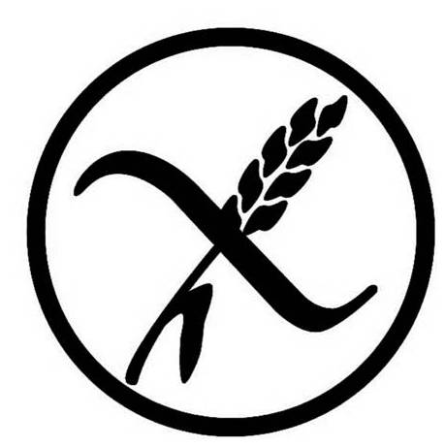

I declare that the products I am submitting comply with the Commission Implementing Regulation (EU) No 828/2014

Signature
Date
1. Company details
Company name
Company address
Registered company name
(if different from the above)
Registered company address
(if different from the above)
Registered company number
Your name
Your job title
Contract signatory name
(if different from the above)
Contract signatory job title
(if different from the above)
Your telephone number
Your email address
Company website address
Company telephone number (customer facing)

PR Agency or Marketing Contact Details
Agency Name
Contact Name
Telephone no.
Email Address

Accounts Payable Contact Details
Contact Name
Telephone no.
Email Address
Company VAT number (if applicable)
Purchase Order Number (if applicable)
- About your company turnover

Annual turnover of gluten-free products within the country of your company headquarters
Annual turnover of gluten-free products within Europe,
excluding the country of your company headquarters (if applicable)
Percentage of business turnover within Europe,
excluding the country of your company headquarters
Annual turnover of gluten-free products outside of Europe
(if applicable)
Percentage of business turnover outside of Europe
Total percentage exports

- About your products:
Please list the product/s that you wish to use the Crossed Grain Trademark (CGT) on and indicate which of the below categories the product falls under. Tick all that apply and provide a valid test certificate for each product. Use an additional sheet of paper, if necessary.

Product Brand Name* | Description | max. or less than 20 ppm gluten content | Contains OATS
* Please ensure that you add the brand name particularly if it is different to the company name

Date on which you would like the licence to start (must be the 1st of any month)
Date on which your products become available to consumers
Where will your products be available from?
(For example, nationwide, locally, supermarkets, health food shops, online shops, etc.)
- Where your products will be available outside of the country of your company’s headquarters?

Country | Percentage Export
Andorra
Austria
Belgium
Croatia
Cyprus
Czech Republic
Denmark
Estonia
Finland
France
Germany
Greece
Hungary
Ireland
Italy
Luxembourg
Malta
Netherlands
Norway
Poland
Portugal
Romania
Russia
Serbia
Slovakia
Slovenia
Spain
Sweden
Switzerland
Ukraine
United Kingdom
Other European countries
(please specify)

If you are exporting to countries outside of Europe, you will require a different licence – a Global Licence. For more information, please contact the Association of European Coeliac Societies (AOECS) at els@aoecs.org

